Module Six Activity: Concurrent Memory Management Simulation
A Mark-and-Sweep Collector for a Multithreaded Embedded Runtime

[Your Name]
Southern New Hampshire University
CS 660: Advanced Programming Language Theory
[Instructor Name]
[Date]

Overview
This activity prototypes a lightweight memory management model for a custom runtime targeting an embedded system that cannot rely on built-in garbage collection. The program, mark_sweep_simulation.py, launches several application threads that concurrently create, link, and release objects inside a shared memory pool of fixed size, while a dedicated collector thread reclaims unreachable memory using a stop-the-world mark-and-sweep cycle. Threading primitives coordinate the two populations of threads so that the heap is never observed in an inconsistent state. The sections below describe the design, present the annotated program output, and evaluate what the simulation demonstrates about memory management under concurrency.

1. Simulation Structure
Responsibility is divided among three types, each owning one concern:

Component | Responsibility
HeapObject | One allocation: its identifier, the thread that created it, its size in bytes, the set of objects it references, and the mark bit used during collection.
MemoryPool | The heap itself: a fixed 256-byte budget, the table of live objects, a per-thread root set modeling each thread's stack frame, and the allocation and collection routines.
MutatorGate | Phase control: permits many application threads to run at once, but lets the collector freeze all of them for the duration of a collection.

An object moves through six stages, and the trace prints an event at each transition:
- Request — a thread asks the pool for a given number of bytes.
- Reservation — the pool verifies the budget and commits the bytes atomically (ALLOC).
- Construction — the object is created and rooted in the requesting thread's frame (CREATE).
- Mutation — the object may be linked beneath a parent, making it reachable indirectly (LINK).
- Release — the thread drops its root reference (DROP). Nothing is freed here; the object merely becomes a candidate.
- Reclamation — a later collection finds it unreachable and returns its bytes to the pool (RECLAIM).

Two design decisions shape everything else. First, the pool is bounded. A fixed capacity means exhaustion is reachable within a run of only a few dozen allocations, so the trace shows the allocator refusing a request and then recovering — the behavior that matters most on a memory-constrained target. Second, each object carries a set of references to other objects, which makes liveness a question of graph reachability rather than a simple flag. An object that no thread holds can still be live because a live parent points at it, and two objects can reference each other while both are garbage. Getting that distinction right is the entire job of the collector.

2. Multithreaded Python Program
Five threads run concurrently:

Thread | Count | Role
MainThread | 1 | Launches the workers, joins them, then runs a final shutdown sweep with an empty root set.
Mutator-1..3 | 3 | Application threads: allocate objects, link them together, release them.
Collector | 1 (daemon) | Periodic stop-the-world mark-and-sweep every 40 ms.

Each mutator performs five steps. Every step allocates an object of 16 to 40 bytes and then assigns it one of three fates, chosen so that all the interesting reachability cases actually occur in a short run:
- Retained — the object stays rooted in the thread's frame.
- Adopted — the object is linked beneath one the thread already holds and its direct root is dropped, so it survives only through its parent.
- Abandoned in a cycle — the object is paired with the previous one into a mutual reference and both roots are dropped.

Threads sleep briefly between operations to simulate real work and to produce genuinely interleaved execution rather than three sequential bursts.
A note on the global interpreter lock. It is a common misconception that Python's GIL makes threaded code race-free. It does not. The GIL guarantees only that a single bytecode instruction is not interrupted. A compound operation such as self._used += size, or the test-then-commit sequence inside allocate(), spans several bytecodes and can be preempted partway through. The locks in this program are therefore doing real work rather than serving as decoration.

3. Concurrent Access
Three primitives operate at three different granularities:

Primitive | Protects | Hazard prevented
threading.Lock  (EventLog) | Standard output | Interleaved, unreadable log lines. A single print() performs several writes and is not atomic.
threading.RLock  (MemoryPool) | Object table, byte counter, root sets, statistics | Lost updates and pool overflow. Reentrant because collect() calls helpers that reacquire the same lock.
threading.Condition  (MutatorGate) | Execution phase | The collector tracing a heap that is being mutated underneath it.

The central race lives in allocate(). The sequence “test whether the request fits, then commit the bytes” is a check-then-act. If two threads each ran the test before either committed, both would pass and the pool would exceed its declared budget. Enclosing the test and the commit in one critical section removes the window. The same reasoning applies to every statistic: total_allocated += 1 is a read, an add, and a write, and losing one increment silently corrupts the final accounting.
Writer preference. Once a collection is pending, arriving mutators wait at the gate rather than slipping in ahead of the collector. Without this, a steady stream of allocations could starve the collector indefinitely and the pool would fill even though reclaimable garbage was present.
Lock ordering and self-deadlock. Threads always acquire the gate before the pool lock and never the reverse; a consistent global ordering is what prevents the classic two-lock deadlock. A subtler hazard is that a thread already counted as an active mutator cannot request a collection, because stopping the world waits for the active count to fall to zero and the requester would be waiting on itself. Each worker therefore leaves its critical section before asking for a collection. The trace shows the resulting handshake at 44.68 ms: the collector announces that it is waiting for one active mutator, and roughly 2.8 ms later Mutator-3 reaches the gate and parks until the collection completes.

4. Mark-and-Sweep Memory Cleanup
Mark. Every mark bit is cleared. The union of all per-thread root sets becomes the initial worklist. The collector then traverses breadth-first, following each object's references and marking everything it reaches. Whatever remains unmarked when the worklist empties is unreachable from any thread.
Sweep. Each unmarked object is removed from the object table and its bytes are returned to the pool's free budget.
Why tracing rather than reference counting. The run contains two deliberate reference cycles. At 43.78 ms Mutator-2 links obj#5 and obj#7 to each other and drops both roots. Each still has one incoming reference, so a reference-counting collector would see a non-zero count for both and leak 56 bytes permanently. A tracing collector asks a different question — is this reachable from a root? — and swept both in cycle 1. The second cycle, obj#4 and obj#8, was reclaimed the same way in cycle 2. This is the clearest demonstration in the program of why production runtimes trace.
Transitive liveness and transitive death. At 32.10 ms obj#6 is linked beneath obj#1 and its direct root is dropped. Cycle 1 nevertheless reports six of eight objects reachable, because obj#1 still points at obj#6 even though no thread holds obj#6 directly. At 71.33 ms Mutator-1 drops obj#1; obj#6 loses its last path from any root, and cycle 2 sweeps both. Liveness propagates forward along references, and so does death.
Why the world must stop. If a mutator could root a new object after the collector had already traversed that region of the graph, the object would finish the mark phase unmarked and be swept while still in use — a use-after-free introduced by the collector itself. Freezing the mutators for the duration of the trace is the simplest correct answer, and it is what this simulation implements.

5. Runtime Events
Every significant transition is printed through a single lock-protected sink, tagged by category so the interleaved trace remains readable:

Tag | Meaning
THREAD | Thread lifecycle and coordination (start, finish, safepoint pause)
ALLOC | The pool grants bytes for a new object
CREATE | The object is constructed and rooted in a thread's frame
LINK | One object stores a reference to another
DROP | A thread releases a root reference; the object may now be garbage
OOM | Allocation refused because the pool is exhausted
GC-STOP | Stop-the-world requested, mutators paused, world resumed
GC-MARK | Mark phase tracing reachability from the root set
RECLAIM | Sweep phase reclaiming an unreachable object's memory
GC-DONE | Collection finished; pool utilization reported

Each line carries a millisecond timestamp and the name of the thread that produced it, so the interleaving of the four active threads is directly visible.
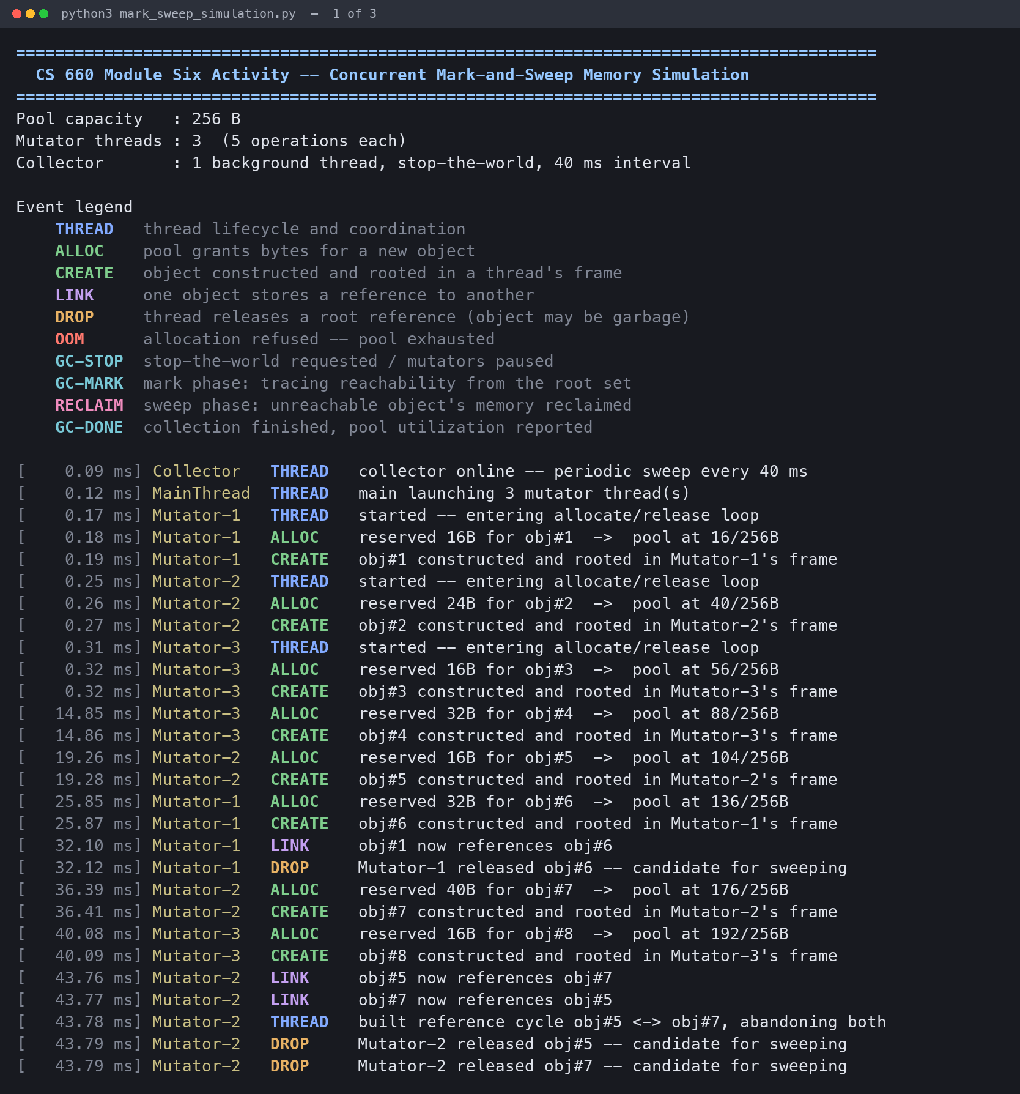
Figure 1. Startup and concurrent allocation. Three mutators interleave allocations into the shared pool. At 32.10 ms obj#6 is linked beneath obj#1 and its root dropped; at 43.76 ms Mutator-2 builds the reference cycle obj#5 ↔ obj#7 and abandons both.
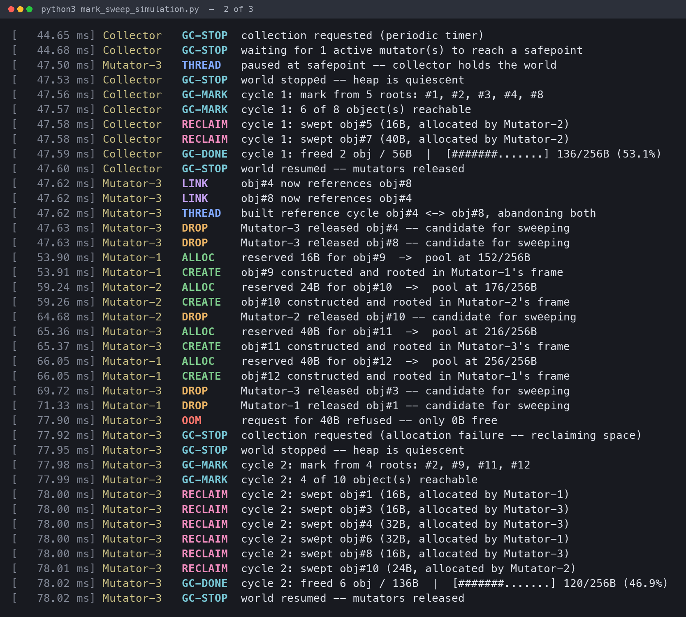
Figure 2. Collection under contention. The collector requests a stop-the-world at 44.65 ms, waits for one active mutator, and Mutator-3 parks at a safepoint. Cycle 1 marks six of eight objects and reclaims the abandoned reference cycle. At 66.05 ms the pool reaches 256/256 bytes; at 77.90 ms a 40-byte request is refused, triggering an on-demand collection that frees 136 bytes.
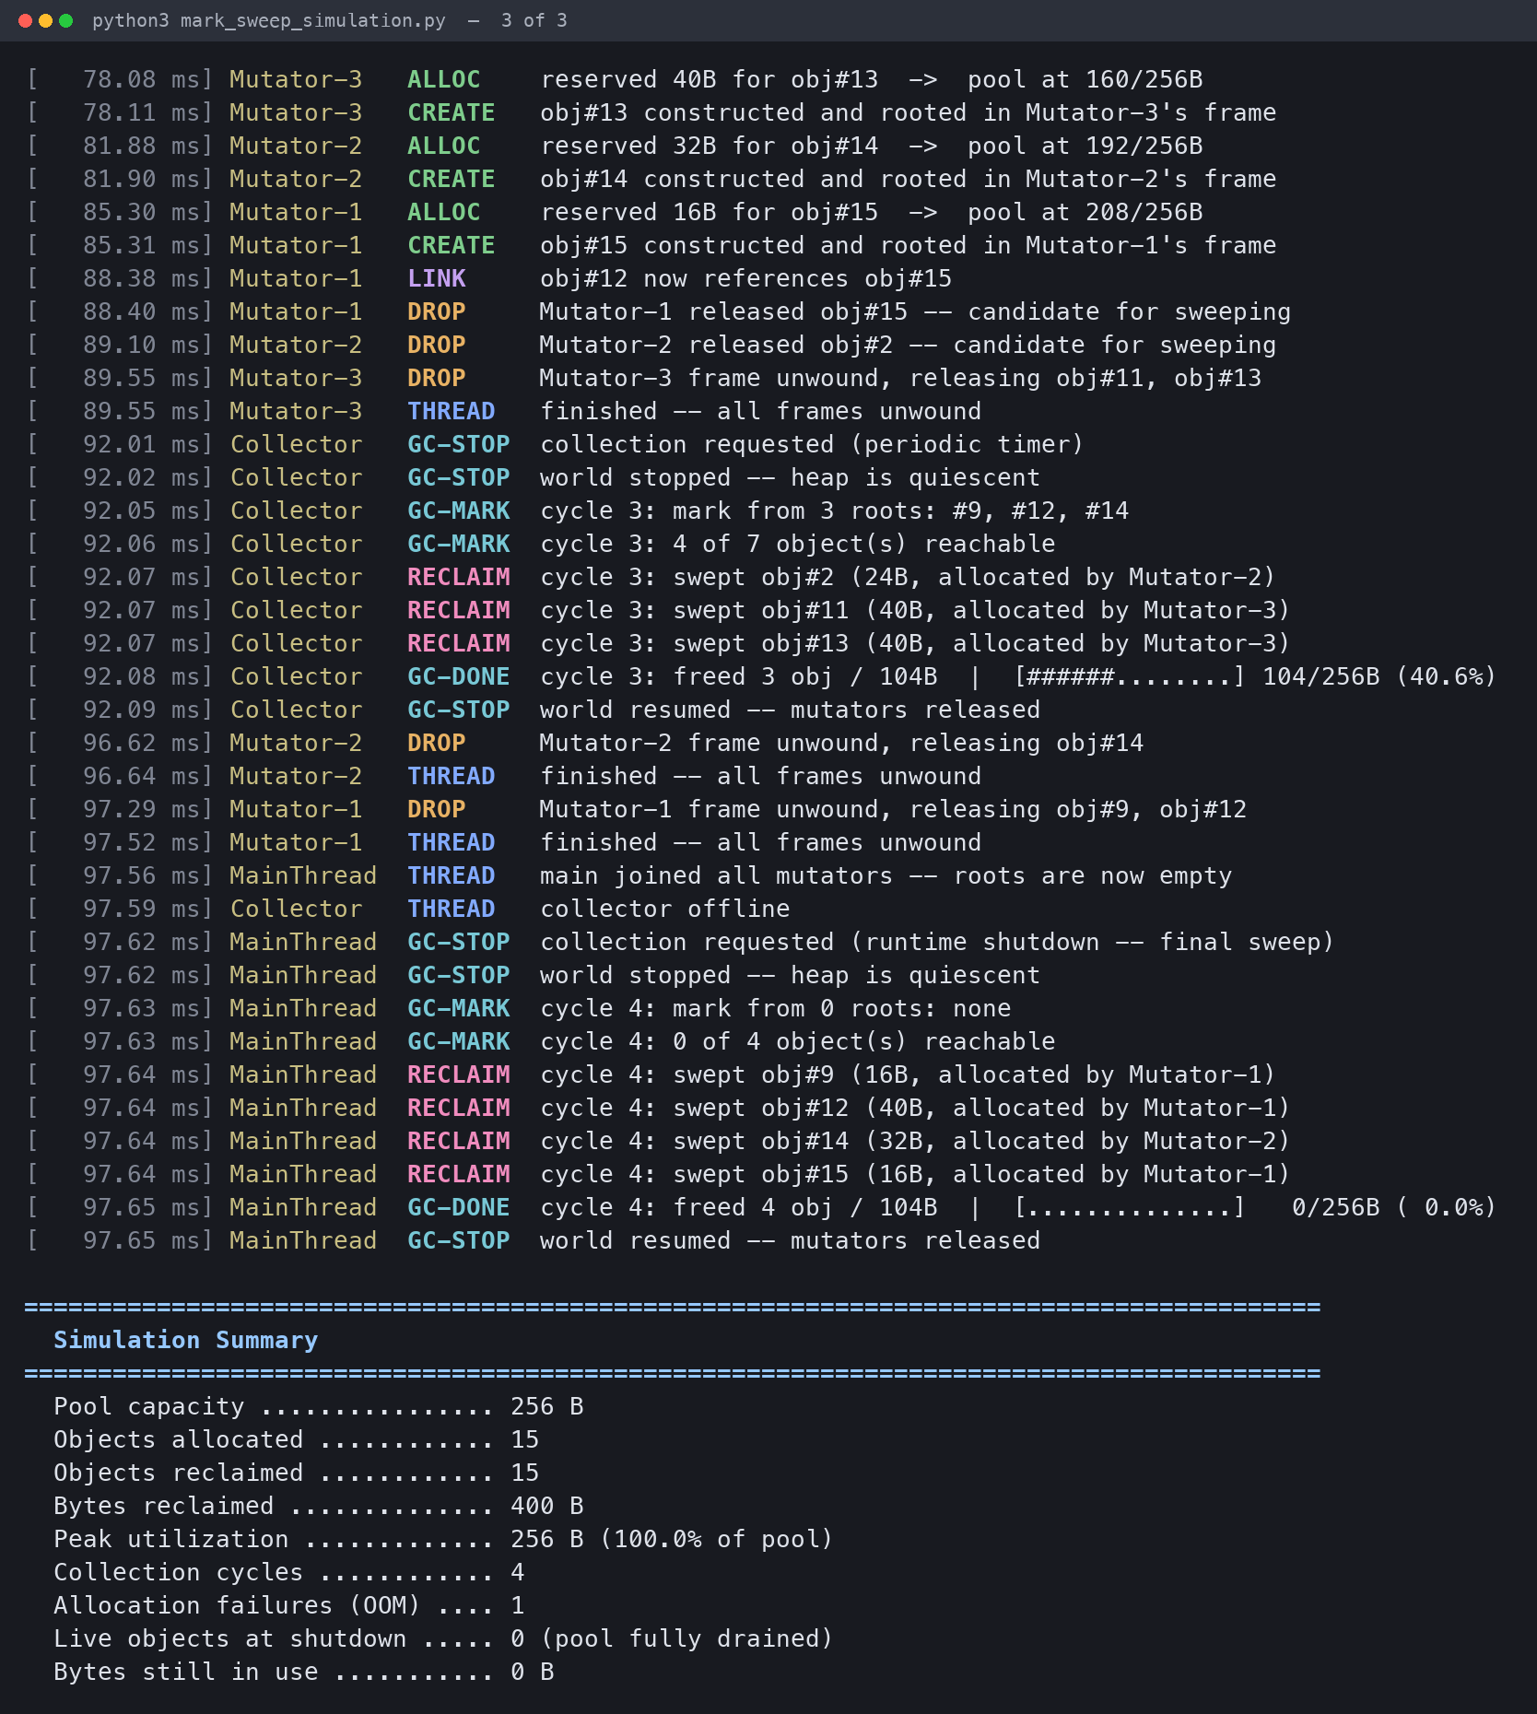
Figure 3. Recovery and shutdown. The retried allocation succeeds immediately after the on-demand collection. Cycle 3 runs on the periodic timer, and the shutdown sweep at 97.62 ms traces from an empty root set and drains the pool to zero. All fifteen objects allocated were reclaimed.

6. Evaluation: Challenges and Solutions
The simulation reproduces, in miniature, most of the problems a real concurrent runtime has to solve, and it makes the cost of each solution visible.

6.1 Shared mutable state and race conditions
Every field of the memory pool — the object table, the used-byte counter, the per-thread root sets, and the statistics — is reachable from four threads at once. The check-then-act in the allocator is the sharpest example: without mutual exclusion, two threads could both be told a request fits and the pool would silently overflow the budget it exists to enforce. The solution is unglamorous and effective: one lock, held across the whole compound operation rather than around each individual field access. The broader lesson is that the unit of atomicity must be the invariant, not the variable.

6.2 Interference between the collector and the application
A collector that traces a heap while threads mutate it can reach a wrong answer in the most dangerous direction: marking an in-use object as garbage and freeing it. Coordinating this needed a second primitive at a different granularity than the pool lock. The gate permits unlimited concurrency among mutators, since the pool lock already protects the data structures from them, while giving the collector exclusive access when it needs the graph to hold still. Separating phase control from data protection is what keeps the design comprehensible; a single lock covering both would have serialized the mutators against each other for no reason.

6.3 Cyclic garbage
Reference counting is simpler and reclaims memory promptly, but it cannot free a cycle, because every object in one retains a non-zero count. The two cycles built deliberately in this run — 56 bytes and 48 bytes — would have leaked under counting and were reclaimed under tracing. On a device with a 256-byte budget, leaking 104 bytes across a few operations would be fatal within seconds. This is the concrete reason the prototype traces rather than counts.

6.4 Exhaustion as a normal condition, not a crash
Under concurrency the pool can fill between one thread's decision to allocate and another's. Treating that as a fatal error would make the runtime unusable. Instead a refused allocation returns a sentinel, the thread requests a collection and retries once, and the trace shows this working: the request for 40 bytes at 77.90 ms is refused with zero bytes free, the resulting collection frees 136 bytes, and the retry succeeds within 200 microseconds. Allocation failure becomes a scheduling signal rather than a failure mode.

6.5 Collector starvation and deadlock
Two coordination bugs were designed out rather than debugged out. Making the gate writer-preferring prevents a continuous stream of allocations from postponing collection forever. Fixing a global lock order, and ensuring a thread never requests a collection while it is itself counted as an active mutator, prevents both the two-lock deadlock and the subtler case of a thread waiting on its own participation. Both hazards are invisible in a single-threaded design and neither produces a useful error message when it occurs — the program simply stops.

6.6 Nondeterminism and how to test it
Because thread scheduling is not reproducible, the program does not produce identical output twice even with object sizes seeded. This is the practical difficulty that makes concurrency bugs expensive: a defect may appear in one run out of hundreds. The response is to assert invariants rather than exact output. Running the simulation fifteen times, every run allocated fifteen objects and reclaimed all fifteen, and the pool drained to zero bytes at shutdown. What varied was the timing of collection, not its correctness: runs ended with four or five collection cycles, one or two allocation failures, and peak utilization between 232 and 256 bytes. Correctness held constant while performance characteristics moved, which is exactly the property a memory manager should have.

6.7 The pause-time tradeoff
Stop-the-world is correct and simple, and the trace shows what it costs: at 44.68 ms the collector blocked all application progress for roughly three milliseconds waiting for a single mutator to reach a safepoint, before doing any useful work. On a three-thread toy that is negligible. Scaled to a real heap with many threads and hundreds of thousands of objects, mark time grows with the live set and pause times become the dominant complaint against tracing collectors. This is the pressure that produced generational collection, which exploits the observation that most objects die young; incremental and concurrent collectors, which interleave marking with mutation using write barriers; and region-based schemes such as Rust's ownership model, which avoid runtime tracing altogether. A production version of this embedded runtime would most plausibly move to an incremental collector to bound worst-case pause length.

Limitations
- The pool tracks a single scalar of used bytes, so it models capacity but not fragmentation; a real allocator can fail a request while nominally holding enough free memory, and no compaction is simulated.
- Allocations are simulated accounting rather than real memory, so the program demonstrates the algorithm rather than measuring true allocator performance.
- Because of the global interpreter lock, the threads interleave rather than execute in parallel on separate cores. The synchronization hazards are identical, but the timing profile of a genuinely parallel runtime would differ.

Conclusion
The simulation meets its goal: objects are created and reclaimed across concurrent threads, shared state is protected by locks chosen at appropriate granularities, and a mark-and-sweep cycle correctly reclaims unreachable memory including reference cycles that a counting collector could not free. More usefully, it makes the tradeoffs legible. Safety under concurrency was obtained by constraining when threads may run, and that constraint is visible in the trace as measurable pause time. That exchange — correctness purchased with throughput — is the central design tension in every real memory manager, and it is the reason garbage collection remains an active area of language runtime research rather than a solved problem.

Note on Generative AI Use
[Adapt or remove per your course's AI policy. If you used a generative AI tool while developing or documenting this program, disclose it here and cite the tool according to the Shapiro Library's guidance, as directed in the assignment's AI Usage section.]

